ARTIFICIAL INTELLIGENCE

This Report is Submitted By –

NAME – Raghav Sharma, Kushal Srivastava, Sanchit Raj, Namit Sharma

ROLL NUMBER – 102016102, 102116097, 102116112, 102116105

TOPIC

Developing a model using any existing dataset

INDEX

|  |  |  |
| --- | --- | --- |
| S.No. | Topic | Pg. No. |
| 1. | Abstract | 2 |
| 2. | What is AI? | 3 |
| 3. | Applications in AI | 4 |
| 4. | Challenges in AI | 5 |
| 5. | Book recommendation – a Brief Intro,  Challenges, Problem Statement, Dataset Used | 7-8 |
| 6. | Hardware and Software Requirements | 9 |
| 7. | Snapshots of Code | 10 |
| 8. | Conclusion & Future Works | 15-16 |
| 9. | References | 17 |

ABSTRACT

"Book Recommendation" is a comprehensive guide for book lovers seeking the perfect read. With an emphasis on diverse voices and genres, this book offers a curated selection of titles for all tastes and interests. From classic literature to contemporary bestsellers, the recommendations are carefully crafted to meet the needs of every reader. Written in an engaging and accessible style, this book is an indispensable resource for anyone looking to expand their reading horizons and discover new authors and stories. Whether you're a seasoned reader or just starting out, "Book Recommendation" is the ultimate guide to finding your next favourite book.This report gives an overview of a model, solely developed to recommend a book using an existing dataset.

What Is Artificial Intelligence?

AI is a wide-ranging branch of computer science concerned with building smart machines capable of performing tasks that typically require human intelligence.

Applications of AI

1. ASTRONOMY – to solve complex universe problems.
2. HEALTHCARE – to help doctors with diagnoses and can inform when patients are worsening so that medical help can reach to the patient before hospitalization.
3. GAMING – games like chess, etc.
4. DATA SECURITY – AI can be used to make data more safe and secure. Examples such as AEG bot, AI2 Platform, are used to determine software bug and cyber attacks in a better way.
5. ROBOTICS – Intelligent robots can be made which can perform tasks with their own experiences without being pre-programmed.

Challenges in AI

1. LIMITED KNOWLEDGE – Many myths are floating about how strong AI can be made that it could even end the world. Also there are very few AI experts that can apply AI solutions to real-life business problems.
2. HIGH COMPUTING POWER – It takes up a lot of computing power to train the AI. As deep learning algorithms become more and more complex, it becomes even more difficult to arrange the number of cores and GPUs they require to work efficiently.
3. DATA SCARCITY – AI algorithms work from the data already available. Therefore, the better the data they are provided, the better the final algorithm will be. However, this requires a lot of data that may sometimes not even be available.
4. BLACK BOX PROBLEM - AI algorithms are like block boxes, which means humans know what the prediction generated by the algorithm is but they don’t know how it arrived at that prediction. This means that people have no means of understanding the inner working of AI algorithms.

Book recommendation system– a Brief Introduction

A book recommendation system is an algorithm designed to suggest books to readers based on their preferences and reading habits. It takes into account various factors such as genre, author, and ratings to provide personalized recommendations to readers. In this book, we will explore the world of book recommendation systems and provide insights on how they work, what makes them effective, and how readers can use them to discover their next favorite book. Whether you are an avid reader or just looking to dive into the world of books, this book will be an invaluable resource in helping you find the perfect read..

Book recommendation system – Challenges

1. Cold start problem: One of the biggest challenges for a book recommendation system is the cold start problem. This occurs when a user is new to the system and has not provided any explicit feedback or data on their reading preferences. In this case, the system may struggle to provide accurate recommendations.
2. Limited data: Another challenge is the limited data available for a particular user. For instance, if a user has only read a few books or has not rated any books, the system may not have enough data to generate accurate recommendations.
3. Genre bias: Many book recommendation systems use genre as a primary factor in generating recommendations. However, this can lead to genre bias, where users are only recommended books within a limited set of genres, and they may not discover books outside of their comfort zone.
4. Stale recommendations: A book recommendation system may also struggle with providing fresh and diverse recommendations. Users may receive the same recommendations repeatedly or be limited to popular titles, which can become stale and uninteresting over time.

Book recommendation system – Problem Statement

The problem statement for a book recommendation system is how to develop a system that can effectively recommend books to users and provide a seamless and enjoyable reading experience.

Book recommendation system – Dataset Used

The dataset that we have used in this project has been taken from Kaggle.

In the dataset, there is data about name of the book, author, user ratings, reviews, price of the book, genre, year of release.

**Book recommendation system** –

Hardware and Software Requirements

1. HARDWARE REQUIREMENTS –

* Processor - 11th Gen Intel(R) Core(TM) i5-1135G7 @ 2.40GHz 1.38 GHz
* Operating System – Windows 11
* Memory - 8.00 GB (7.73 GB usable)
* System type - 64-bit operating system, x64-based processor

1. SOFTWARE REQUIREMENTS –

* Google Collaboration , IDLE Python Interpreter

**Book recommendation system** –

Code and Output Snapshots in Google Colab:

The whole dataset is divided in 4:1 ratio. The initial 80 percent dataset has been used to train the model and the remaining 20 percent model has been used to test the model.

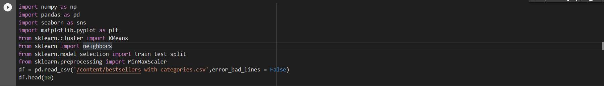

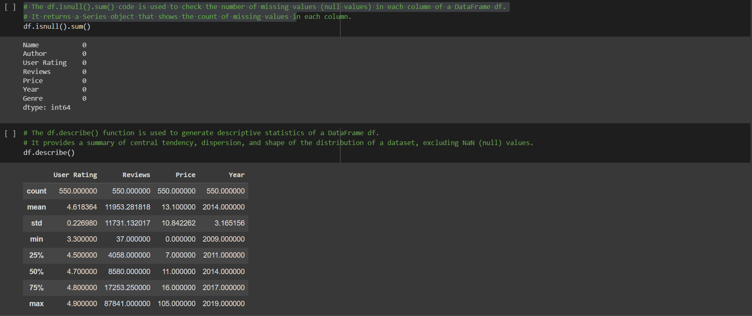  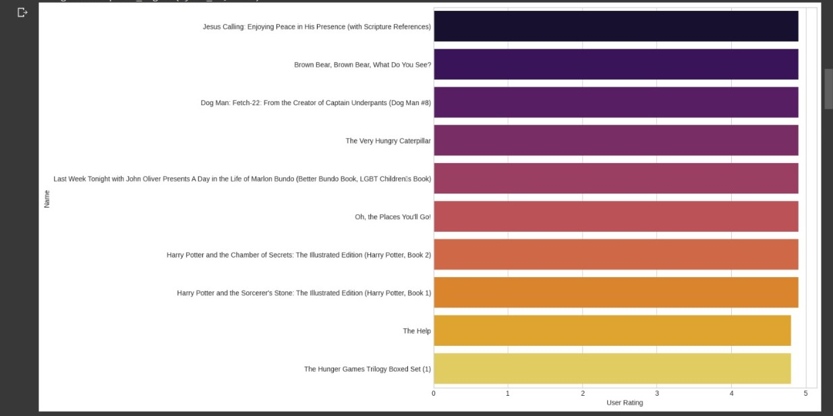

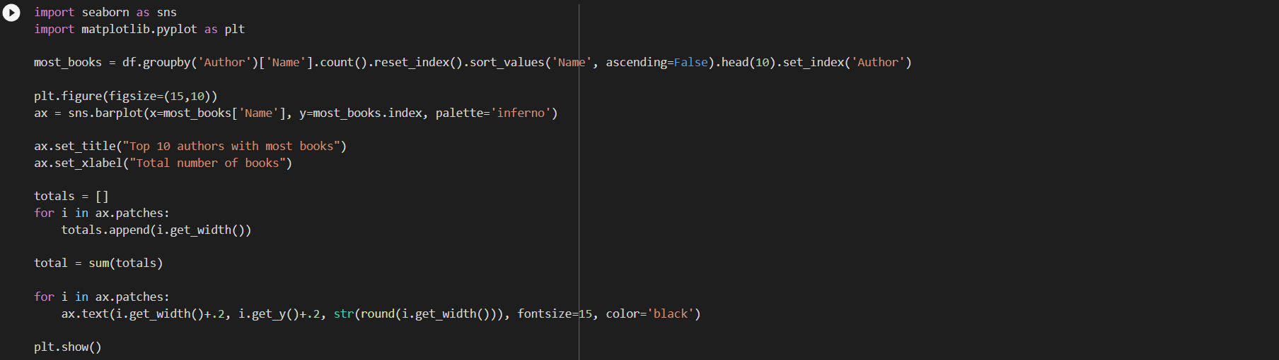

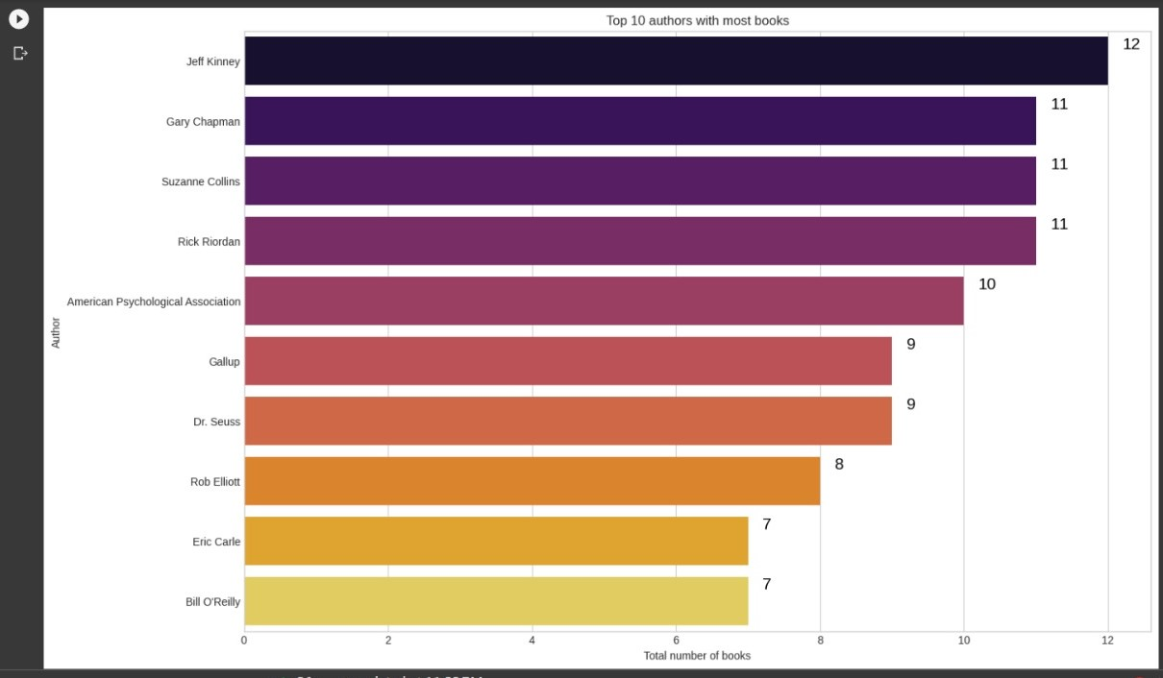

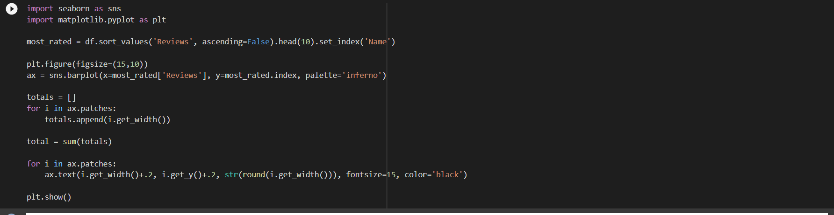

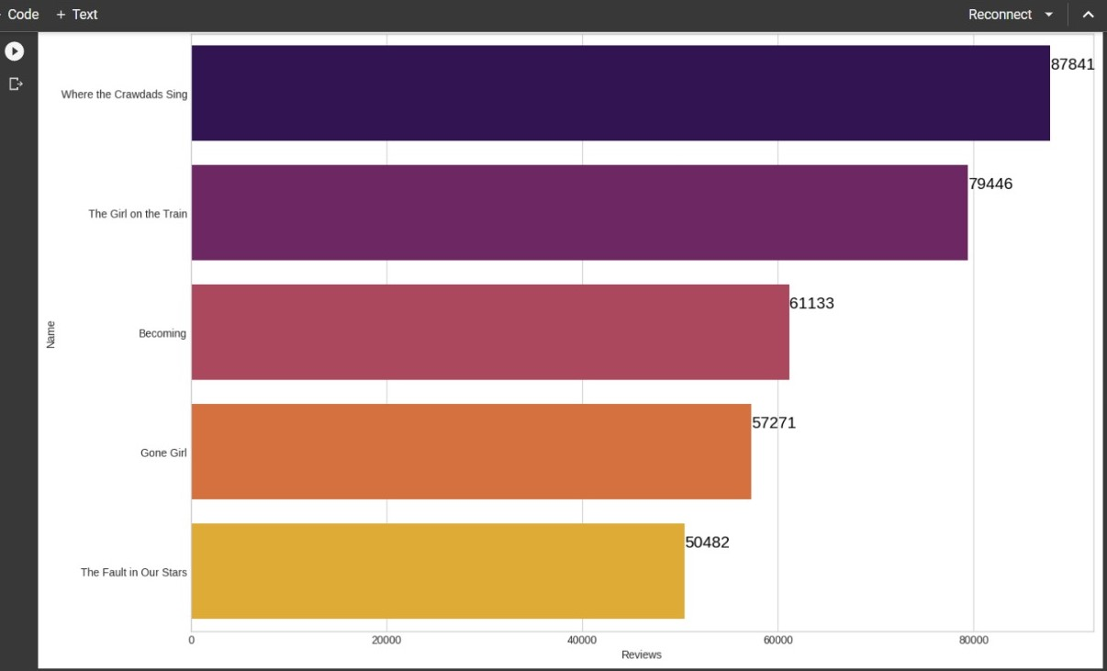

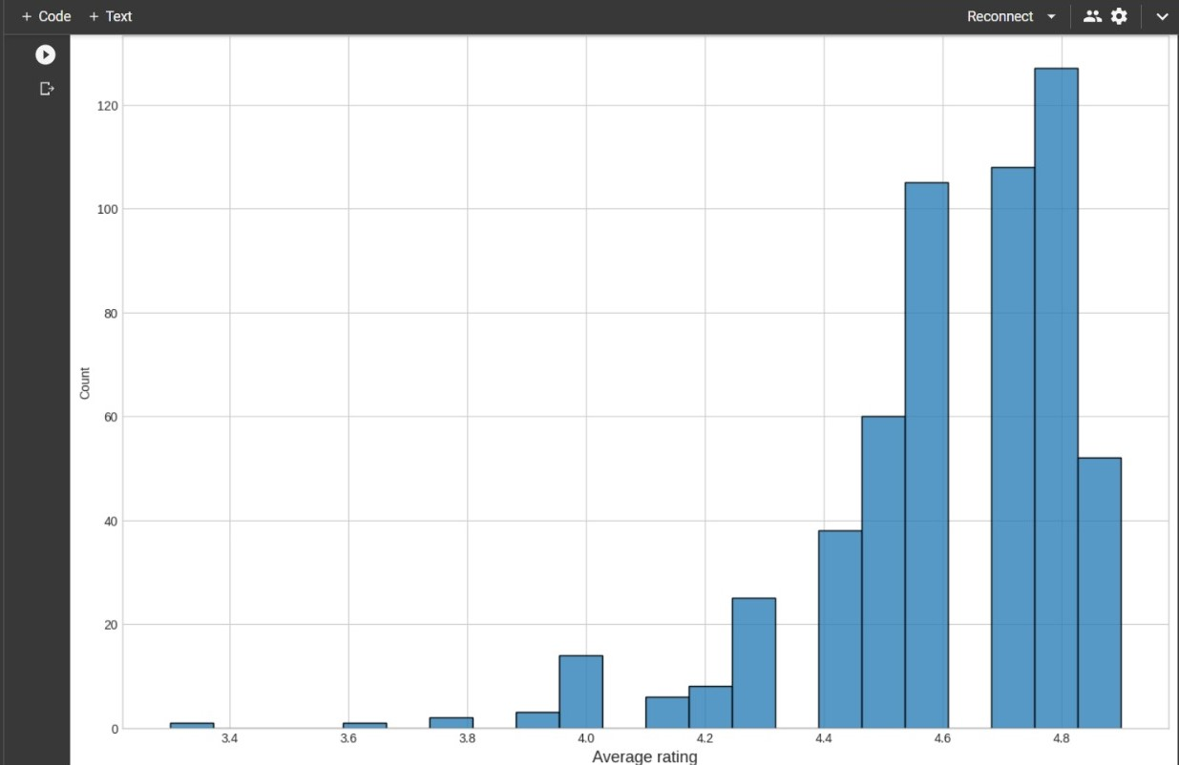



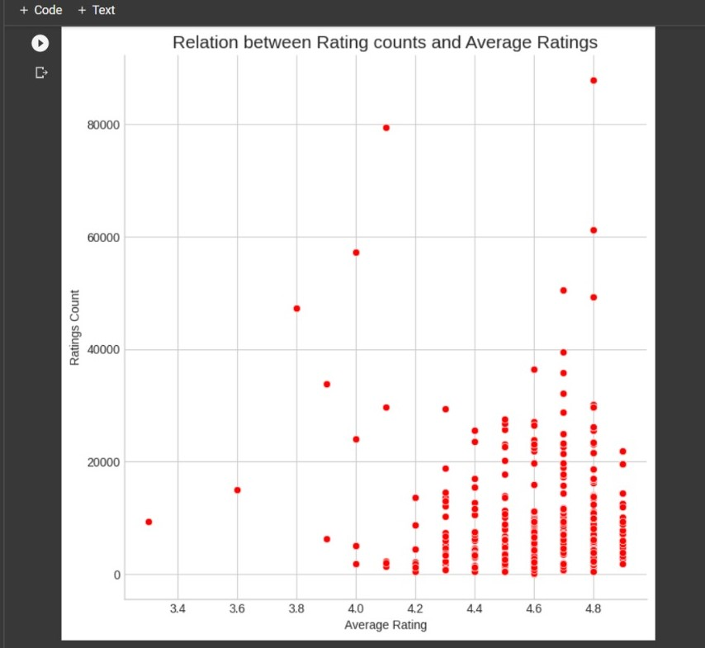

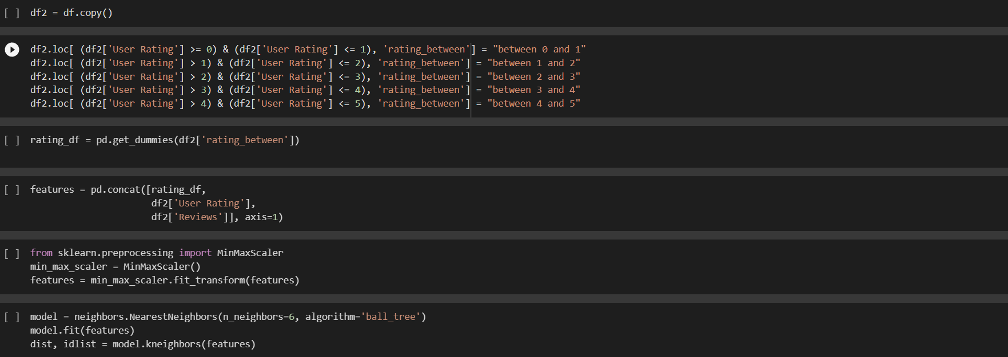

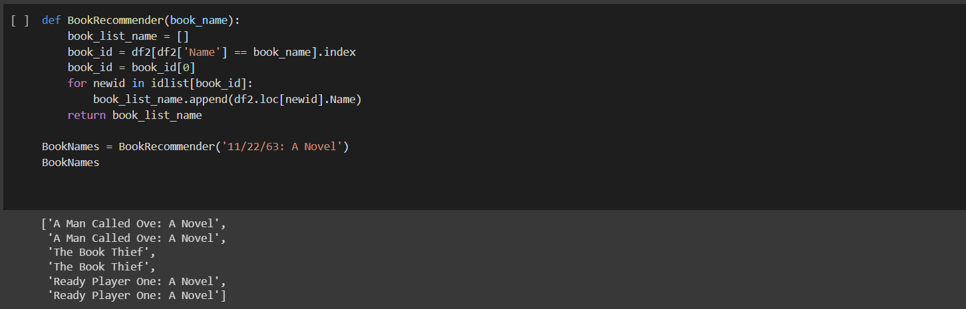

**Book recommendation system**

Conclusion:

In conclusion, a book recommendation system is a valuable tool for both bookstores and readers. There are different types of recommendation systems such as collaborative filtering, content-based filtering, and matrix factorization. Each has its strengths and weaknesses and can be implemented using various machine learning algorithms such as K-nearest neighbors, decision trees, and deep learning. The success of a recommendation system depends on the quality of the data and the algorithm used to make recommendations. By leveraging data analytics and machine learning techniques, bookstores can provide better recommendations to their customers, leading to increased customer satisfaction and loyalty.

**Book recommendation system** –

Future Works

Future works in book recommendation systems will focus on developing more transparent and explainable algorithms, incorporating contextual and multi-modal data, improving the efficiency of active learning algorithms, and providing users with more diverse and serendipitous recommendations. Ultimately, the goal of a book recommendation system is to provide users with personalized and relevant recommendations that help them to find books that they will enjoy and cherish. With the continued evolution of technology and machine learning, the future of book recommendation systems looks promising, and we can expect to see many exciting developments in the years to come.

REFERENCES

* [About AI](https://builtin.com/artificial-intelligence)
* [Challenges](https://www.geeksforgeeks.org/top-challenges-for-artificial-intelligence-in-2020/)
* [Dataset](https://www.kaggle.com/datasets/sootersaalu/amazon-top-50-bestselling-books-2009-2019)